Name: Rishabh Singhal

Roll No: 2K19/CO/317

**Question 1: Explain asynchronous data transfer using both strobe pulse and handshaking. Support your answer with block diagram and sequence of events.**

Asynchronous Data transfer between two independent units requires that control signals be transmitted between the communicating units to indicate the time at which data is being transmitted.

One way of achieving this is by means of a strobe pulse supplied by one of the units to indicate to the other unit when the transfer has to occur.

Another method commonly used is to accompany each data item being transferred with a control signal that indicates the presence of data in the bus. The unit receiving the data item responds with another control signal to acknowledge receipt of the data. This type of agreement between two independent units is referred to as handshaking.

**Strobe Control**

The strobe control method of asynchronous data transfer employs a single control line to time each transfer. The strobe may be activated by either the source or the destination unit.

Source Initiated transfer:

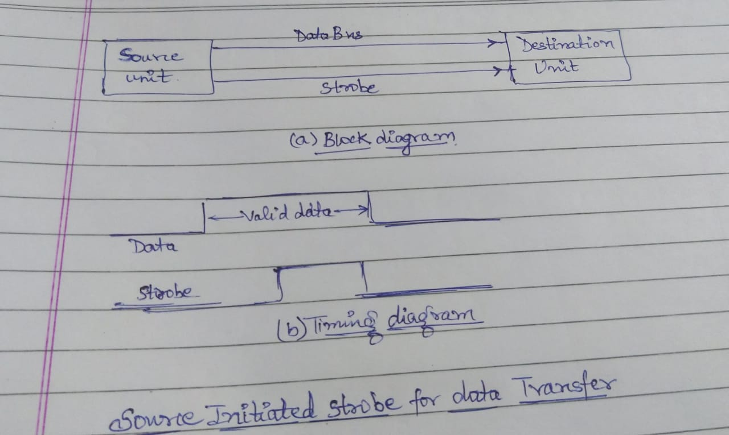

The data bus carries the binary information from source unit to the destination unit. Typically, the bus has multiple lines to transfer an entire byte or word. The strobe is a single line that informs the destination unit when a valid data word is available in the bus.

As shown in the timing diagram, the source unit first places the data on the data bus. After a brief delay to ensure that the data settle to a steady value, the source activates the strobe pulse. The information on the data bus and the strobe signal remains in the active state for a sufficient time period to allow the destination unit to receive the data. Often, the destination unit uses the falling edge of the strobe pulse to transfer the contents of the data bus into one of its internal registers. The source removes the data from the bus a brief period after it disables its strobe pulse. Actually, the source does not have to change the information in the data bus.

Destination Initiated transfer

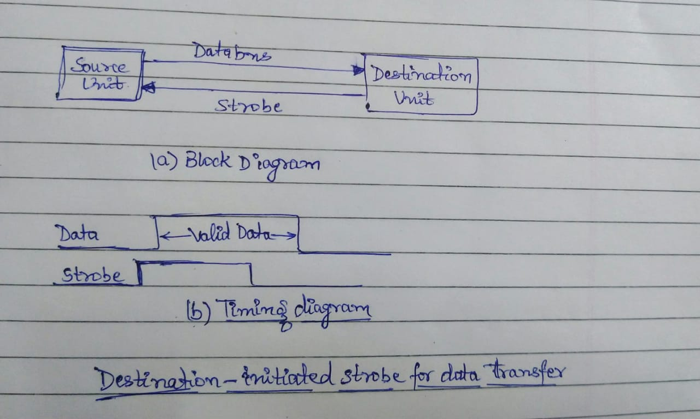

In this case the destination unit activates the strobe pulse, informing the source to provide the data. The source unit responds by placing the requested binary information on the data bus. The data must be valid and remain in the bus long enough for the destination unit to accept it. The falling edge of the strobe pulse can be used again to trigger a destination register. The destination unit. Then disables the strobe. The source removes the data from the bus after a predetermined time interval.

**Handshaking**

The disadvantage of the strobe method is that the source unit that initiates the transfer has no way of knowing whether the destination unit has actually received the data item that was placed in the bus. Similarly, a destination unit that initiates the transfer has no way of knowing whether the source unit has actually placed the data on the bus. The handshake method solves this problem by introducing a second control signal that provides a reply to the unit that initiates the transfer. The basic principle of the two-wire handshaking method of data transfer is as follows. One control line is in the same direction as the data flow in the bus from the source to the destination. It is used by the source unit to inform the destination unit whether there are valid data in the bus. The other control line is in the other direction from the destination to the source. It is used by the destination unit to inform the source whether it can accept data. The sequence of control during the transfer depends on the unit that initiates the transfer.

The source unit initiates the transfer by placing the data on the bus and enabling its data valid signal. The data accepted signal is activated by the destination unit after it accepts the data from the bus. The source unit then disables its data valid signal, which invalidates the data on the bus. The destination unit then disables its data accepted signal and the system goes into its initial state. The source does not send the next data item until after the destination unit shows its readiness to accept new data by disabling its data accepted signal. This scheme allows arbitrary delays from one state to he next and permits each unit to respond at its own data transfer rate. The rate of transfer is determined by the slowest unit.

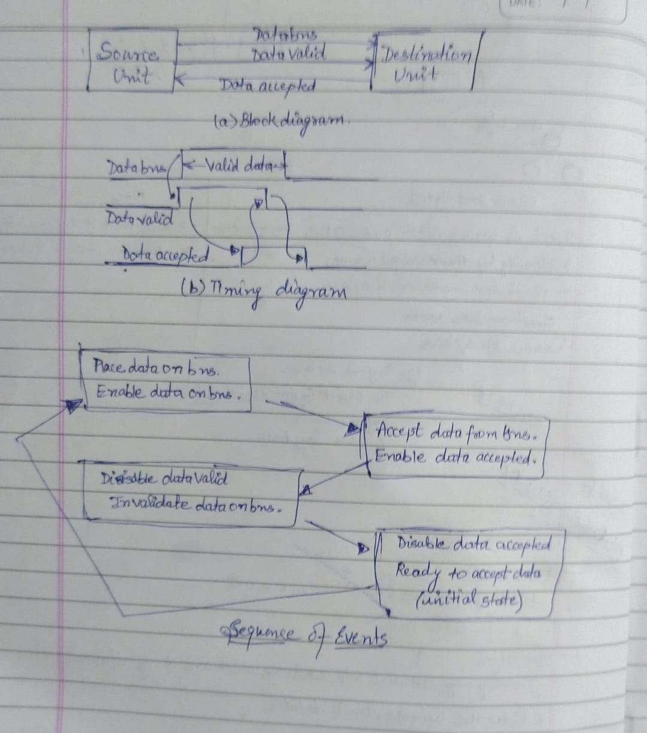

**Question 2: Discuss serial communication.**

**Solution 2.**

A data communication processor is an VO processor that distributes and collects data from many remote terminals connected through telephone and other communication lines. It is a specialized VO processor designed to communicate directly with data communication networks. A communication network may consist of any of a wide variety of devices, such as printers, interactive display devices, digital sensors, or a remote computing facility. With the use of a data communication processor, the computer can service fragments of each network demand in an interspersed manner and thus have the apparent behaviours of serving many users at once. In this way the computer is able to operate efficiently in a time-sharing environment.

In embedded system, Serial communication is the way of exchanging data using different methods in the form of serial digital binary. Some of the well-known interfaces used for the data exchange are RS-232, RS-485, I2C, SPI etc.

In serial communication, data is in the form of binary pulses. In other words, we can say Binary One represents a logic HIGH or 5 Volts, and zero represents a logic LOW or 0 Volts.

Serial communication can take many forms depending on the type of transmission mode and data transfer. The transmission modes are classified as Simplex, Half Duplex, and Full Duplex. There will be a source (also known as a sender) and destination (also called a receiver) for each transmission mode.

**Question 3: Compare Asynchronous and Synchronous Serial Communication.**

Synchronous:

1. Synchronous serial communication describes a serial communication protocol in which "data is sent in a continuous stream at constant rate."
2. Synchronous communication requires that the clocks in the transmitting and receiving devices are synchronized – running at the same rate – so the receiver can sample the signal at the same time intervals used by the transmitter
3. No start or stop bits are required. For this reason, "synchronous communication permits more information to be passed over a circuit per unit time" than asynchronous serial communication.
4. No start or stop bits are required. For this reason, "synchronous communication permits more information to be passed over a circuit per unit time" than asynchronous serial communication.
5. Example: USART

Asynchronous:

1. Instead of a common synchronization signal, the data stream contains synchronization information in form of start and stop signals, before and after each unit of transmission, respectively.
2. Asynchronous serial communication is a form of serial communication in which the communicating endpoints' interfaces are not continuously synchronized by a common clock signal.
3. The start signal prepares the receiver for arrival of data and the stop signal resets its state to enable triggering of a new sequence.

**Question 4: How many characters per second can be transmitted over a 4800 baud rate line in each of the following modes? (Assume character code of 8 bits)**

a) Synchronous serial transmission => 4800/8=600

b) Asynchronous serial transmission with two stop bits => 4800/11 =437

c) Asynchronous serial transmission with one stop bit=> 4800/10 = 480

**Question 5: Describe the following standard communication interfaces**

1. **Peripheral Community Interface(PCI)**

It could be a standard information transport that was common in computers from 1993 to 2007 or so. It was for a long time the standard transport for extension cards in computers, like sound cards, network cards, etc. It was a parallel transport, that, in its most common shape, had a clock speed of 66 MHz, and can either be 32 or 64 bits wide. It has since been replaced by PCI Express, which could be a serial transport as contradicted to PCI. A PCI port, or, more precisely, PCI opening, is essentially the connector that’s utilized to put through the card to the transport. When purge, it basically sits there and does nothing.

Types:

a. PCI 32 bits have a transport speed of 33 MHz and work at 132 MBps.

b. PCI 64 bits have a transport speed of 33 MHz and work at 264 MBps.

c. PCI 64 bits have a transport speed of 66 MHz and work at 512 MBps.

d. PCI 64 bits have a transport speed of 66 MHz and work at 1 GBps.

Functions:

PCI slots are utilized to install sound cards, Ethernet and remote cards and presently strong state drives utilizing NVMe innovation to supply SSD drive speeds that are numerous times speedier than SATA SSD speeds. PCI openings too permit discrete design cards to be included to a computer as well. PCI openings (and their variations) permit you to include expansion cards to a motherboard. The extension cards increment the machines capabilities past what the motherboard may create alone, such as: upgraded illustrations, extended sound, expanded USB and difficult drive controller, and extra arrange interface options, to title a couple of.

Advantages:

1. You’ll interface a greatest of five components to the PCI and you’ll be able moreover supplant each of them by settled gadgets on the motherboard.

2. You have different PCI buses on the same computer.

3. The PCI transport will improve the speed of the exchanges from 33MHz to 133 MHz with a transfer rate of 1 gigabyte per second.

4. The PCI can handle gadgets employing a greatest of 5 volts and the pins utilized can exchange more than one flag through one stick.

Disadvantages:

1. PCI Graphics Card cannot get to system memory.

2. PCI does not support pipeline.

**b) Small computer System interface:**

The basic interface for connecting peripheral devices to a PC is a small computer system interface. Based on the specification, it can typically respond up to 16 external devices using a single route, along with a host adapter. Small Computer System Interface is used to boost performance, deliver fast data transfer delivery and provide wider expansion for machines like CD-ROM drivers, scanners, DVD> drives and CD writers. Small Computer System Interface is most commonly used for RAID, servers, highly efficient desktop computers, and storage area networks. The Small Computer System Interface has control, which is responsible for transmitting data across the Small Computer System Interface bus and the computers. It can be fixed on a motherboard, or one client adapter is installed through an extension on the computer's motherboard. The controller also incorporates a simple SCSI input/output system, which is a small chip that provides access and control equipment with the necessary software. The SCSI ID is his number. Using serial storage architecture initiators, new serial SCSI IDs such as serial attached SCSI use an automatic process which assigns a 7-bit number.

Advantages:

1. Its performance is much faster than IDE or SATA.

2. Many devices (nearly 16) can be attached at the same time on a single controller.

3. The interfacing for different types of devices is done through the same cable.

4. The peripheral devices of the same type have common characteristics so it is easy to replace the old devices.

5. The peripheral devices are independent so the computer can do other work.

Disadvantages:

1. The SCSI drives and hardware are more expensive than IDE or SATA.
2. It may be difficult to configure older models because each device needs a special ID number and correct termination.

**C) Universal Serial bus (USB)**

Universal Serial Bus (USB) is an industry standard that establishes specifications for connectors, cables and protocols for communication, connection and power supply between personal computers and their peripheral devices. There have been 3 generations of USB specifications:

1. USB 1.x

2. USB 2.0

3. USB 3.x

Functions:

USB was designed to standardize the connection of peripherals like pointing devices, keyboards, digital still and video cameras. But soon devices such as printers, portable media players, disk drives and network adaptors to personal computers used USB to communicate and to supply electric power. It is a commonplace to many devices and has largely replaced interfaces such as serial ports and parallel ports. USB connectors have replaced other types for battery chargers of portable devices with itself.

Advantages:

1. The USB interface is self-configuring. This means that the user need not adjust settings on the device and interface for speed or data format, or configure interrupts, input/output addresses, or direct memory access channels.

2. USB connectors are standardized at the host, so any peripheral can use any available receptacle. USB takes full advantage of the additional processing power that can be economically put into peripheral devices so that they can manage themselves. USB devices mostly do not have user-adjustable interface settings.

3. The USB interface is hot pluggable or plug and play, meaning devices can be exchanged without rebooting the host computer. Small devices can be powered directly from the USB interface thus removing extra power supply cables.

4. The USB interface defines protocols for improving reliability over previous interfaces and recovery from common errors.

5. Installation of a device relying on the USB standard minimal operator action is required.

Disadvantages:

1. USB cables are limited in length.

2. USB has a strict “tree” topology and “master-slave” protocol for addressing peripheral devices. Peripheral devices cannot interact with one another except via the host, and two hosts cannot communicate over their USB ports directly.

3. Some very high-speed peripheral devices require sustained speeds not available in the USB standard.

4. For a product developer, use of USB requires implementation of a complex protocol and implies an intelligent controller in the peripheral device.

5. Use of the USB logos on the product require annual fees and membership in the organization.